Mark Scheme for 2010 H1 Chemistry Prelim
Paper 1
- C | - D | - A | - D | - A
- C | - B | - B | - C | - C
- C | - C | - C | - B | - D
- C | - A | - A | - B | - A
- C | - B | - B | - D | - B
- B | - D | - A | - B | - D

Paper 2 Section A
1 (a)
 | type of particles | interactions within the crystals
Copper crystals | cations / Cu²⁺ ions | metallic bonding
Iodine  crystals | I₂ molecule | van der Waals’ forces / dispersion forces  / id-id interactions
(b) The sea of delocalised electrons is able to accommodate any deformation to the cationic lattice
OR The layers of cations can slide past each other while electrons hold them together.
(c) Physical property: electrical conductivity / solubility in organic solvent
Reason:
Conductivity: mobile electrons available to conduct electricity in Cu but no mobile electrons or ions in I₂.
Solubility: similar intermolecular forces of attraction for iodine & organic solvent, thus I₂ can form favourable interactions with the organic solvent , but Cu cannot form favourable interactions with the organic solvent
(d)(i) Relative atomic mass is the weighted average of the masses of the isotopes (or words to this effect).
(ii) % abundance of the isotopes in this sample differs from what is normally obtained.
OR There are more than 2 types of isotopes of copper.
(e)(i) correct direction & angle of deflection.

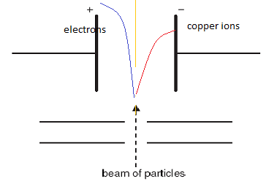
(ii) angle of deflection 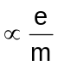
∴ angle of deflection of I⁻ = 7 x 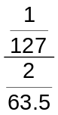 = 1.8º
2 (a)(i)
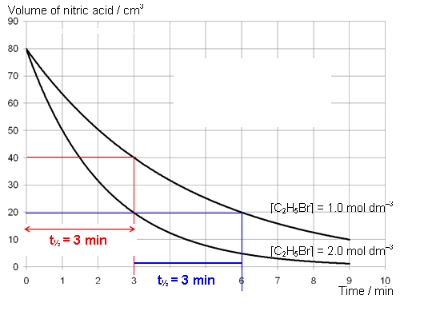
Use graph to show constant t_{1/2} ~3 min.
Reaction is first order wrt aqueous sodium hydroxide.
(ii) Calculation (using initial rates) or other points on the graphs to show that when [C₂H₅Br] doubled, rate (or gradient of the graph) doubled.
Reaction is thus first order wrt to C₂H₅Br
(iii) Rate = k [C₂H₅Br] [OH–]
(b)(i) T₁ < T₂ (label of axes can be different)
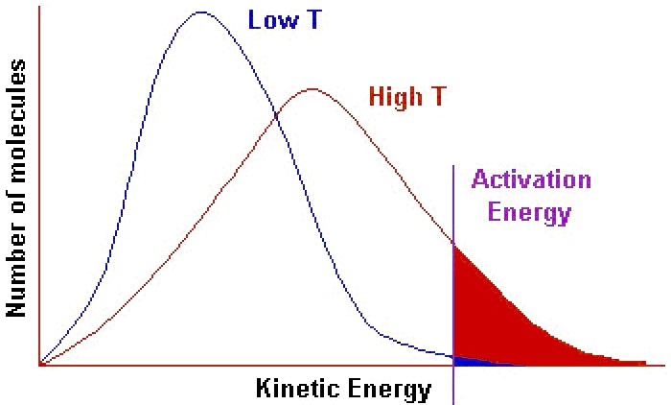
increasing T increases the proportion (number) of molecules with minimum E_{a} for reaction & thus …..
(ii) increase in [C₂H₅Br]
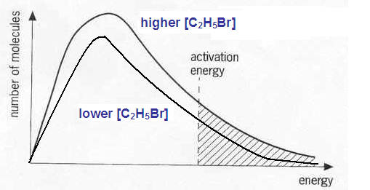
When [C₂H₅Br] increases, collision frequency / number of effective collisions increases as number of molecules with the minimum activation energy increases

3(a)(i) C E
CH₃COCH=C(CH₃)₂ CH₃COCH₂C(OH)(CH₃)₂
F G
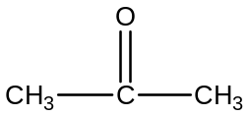 CH₃COCO₂C(CH₃)₂CH₂COCH₃
(ii) Step I: NaOH(aq), heat
Step II: KMnO₄(aq), dil H₂SO₄, heat
(b)
Functional group | Chemical test + Observations
Secondary alcohol | K₂Cr₂O₇(aq), dil H₂SO₄, heat | Orange solution turns green
Secondary alcohol | PCl₅(s) | White fumes HCl
Ketone | 2,4-dinitrophenylhydrazine | Orange ppt
(c) (i) H
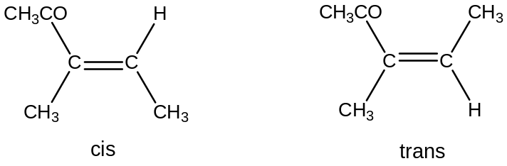
OR
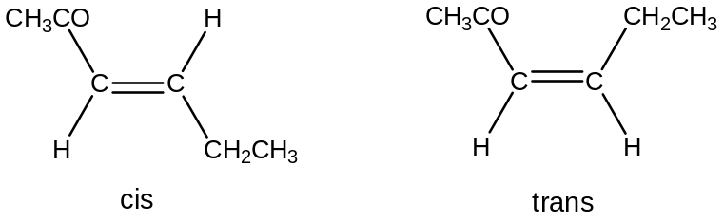
OR
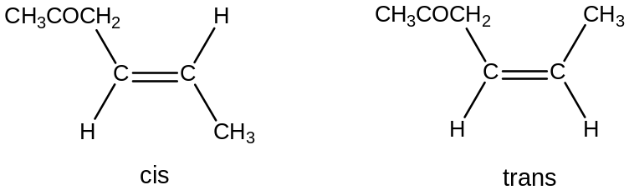
(ii) The C =C bond cannot undergo free rotation as the π bond in C=C bond will be broken.
OR There is a restriction in rotation of C=C bond.

4(a)(i) C₁₃H₁₈O₂
(ii) Mr = 206
Mass = 0.15 x (100/1000) x 206 = 3.10 g
(iii) No. of moles of NaOH = 0.1 x 12/1000 = 1.2 x 10⁻³
No. of moles of acid, J = 0.6 x 10⁻³
M_{r} = 0.1/ 0.6 x 10⁻³ = 167
(M_{r} of 2-CO₂H = 90, thus M_{r} of remaining part = 97, the benzene ring)
Structure of J: 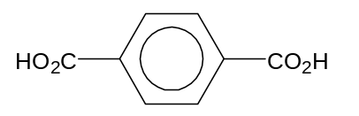
b(i) K_{a} = 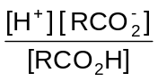
(ii) [H⁺] = √(K_{a} x C) = √(6.3 x 10⁻⁶ x 0.15) = 9.72 x 10⁻⁴ mol dm⁻³
pH = 3.0
(iii) phenolphthalein
pH at equivalence point of a strong base & weak acid titration is about 9, which corresponds to its working range

SECTION B
5(a)(i) A system is said to be in dynamic equilibrium when the rate of forward reaction is equal to the rate of backward reaction.
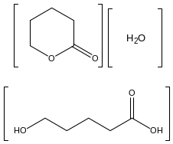
(ii) K_{c} = 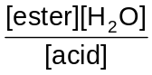 or

(iii) K_{c} = 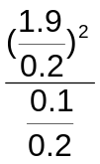 = 180.5 mol dm⁻³

(b)(i) I Order of Reaction with respect to a reactant is the power to which the concentration of that reactant is raised in the rate equation.
II activation energy: energy that must be overcome in order for a chemical reaction to occur / the minimum energy required to start a chemical reaction.
(ii)
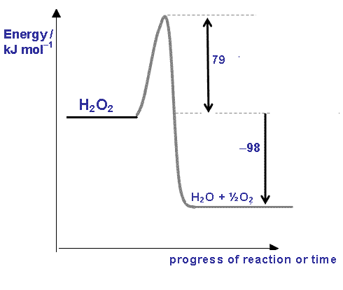
(iii) activation energy is lowered in the presence of enzyme catalase, more molecules have the minimum E_{a} & hence higher collision frequency of collision & higher rate of the decomposition of hydrogen peroxide
(iv) Measure vol of O₂ evolved at various time intervals & plot graph of the vol vs. time to obtain gradient at various t

(c) Q R T S: CHI₃
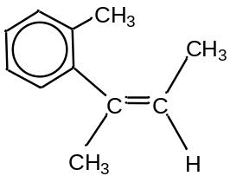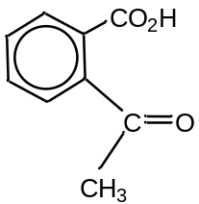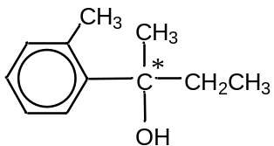

Q → R: Oxidative cleavage of alkene
Q → R: Side-chain oxidation of benzene ring
R undergoes oxidation with alkaline iodine as it is a methyl ketone
Q → T: Hydration of alkene to alcohol
S is a tertiary alcohol as it has no reaction with acidified dichromate(VI)
Q exhibits cis-trans isomerism due to 2 different groups on each C of double bond

6(a) MgCl₂(s) - giant ionic lattice structure with strong electrostatic forces of attraction between Mg²⁺ & Cl¯ ions.
It dissolves in water to form a slightly acidic solution as Mg²⁺ has a high charge density & undergoes hydrolysis in water. MgCl₂(s) + 6H₂O(l) à [Mg(H₂O)₆]²⁺(aq) + 2Cl⁻(aq)
[Mg(H₂O)₆]²⁺(aq) + H₂O(l) [Mg(H₂O)₅(OH)]⁺(aq) + H₃O⁺(aq)
SiCl₄(l) - simple covalent molecules with inter-molecular dispersion forces.
It undergoes complete hydrolysis in water to give a highly acidic solution of pH 1 - 2.
SiCl₄(l) + 2H₂O(l) à SiO₂(s) + 4HCl (aq)
OR SiCl₄(l) + 4H₂O(l) à SiO₂.2H₂O(s) + 4HCl(aq)
(b)(i) I SO₂ is simple molecular
& has weak intermolecular van der Waals forces / pd-pd forces & thus little E is needed to break them & hence low bp
(reject dispersion forces as SO₂ is polar)
II LE 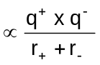; q⁺ of Mg²⁺ > q⁺ of Na⁺ while r₊ of Mg²⁺ < r₊ of Na⁺,
stronger electrostatic forces of attraction between Mg²⁺ & O²⁻ (ionic bonding) in MgO than in Na₂O & hence MgO has a higher mp
III SiO₂ is macromolecular with large no of covalent bonds to be broken for melting to occur;
P₄O₆ is simple molecular with much weaker intermolecular van der Waals forces...
(c)(i)
 | S | Cl
% | 31 | 69
Rel mol | 0.97 | 1.94
ratio | 1 | 2
empirical formula is SCl₂
(ii) Dot-&-cross diagram: 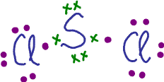
Shape: bent (S has 2 bp & 2 lone pair of electrons)
(d)(i) I: ethanolic KCN, heat
II: dilute H₂SO₄, heat OR dilute HCl, heat
III: PBr₃, heat OR red phosphorus with Br₂, heat
(ii) BE(C-I) = 240 kJ mol⁻¹; BE(C-Br) = 280 kJ mol⁻¹
BE(C-I) is lower, i.e., C-I bond is weaker & is easier to be broken Iodomethane has a higher rate of hydrolysis

7(a)(i) Phosphorus is burned in excess oxygen:
4P(s) + 5O₂(g) à P₄O₁₀(s)
Or P₄(s) + 5O₂(g) à P₄O₁₀(s)
Or 2P(s) + 5/2O₂(g) à P₂O₅(s)
OR ½P₄(s) + 5/2O₂(g) à P₂O₅(s)
Water is added to the resulting oxide:
P₄O₁₀(s) + 6H₂O(l) à 4H₃PO₄(aq)
Or 2P₂O₅(s) + 6H₂O(l) à 4H₃PO₄(aq)
(ii) pH: 1 - 3
(b)(i) Standard enthalpy change of formation – energy change when 1 mol of a compound is formed from its constituent elements at 298 K & 1 atm pressure.
(ii) PCl₅(s) + H₂O(l) 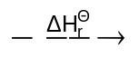 POCl₃(l) + 2HCl(g)

-444 -286 -1186 2(-92)
P(s) + H₂(g) + ½O₂(g) + 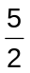Cl₂(g)
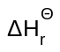 = 2(-92) + (-1186) – {(-444) + (-286)}
= -640 kJ mol^{–1}

c(i) V W Y
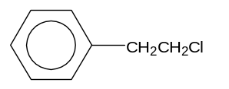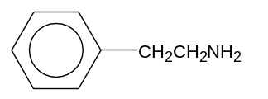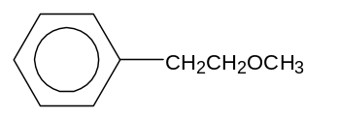
(ii) Acidified K₂Cr₂O₇(aq), heat
(iii) LiAlH₄ in dry ether
(iv) Substitution

(d)(i) I buffer solution: a solution that is able to resist pH changes upon addition of a small amount of an acid or a base.
II Equation for reaction when a small amount of NaOH(s) is added:
H₂PO₄–(aq) + NaOH(s) → HPO₄^{2–}(aq) + H₂O(l) + Na⁺(aq)
Comaprable maounts of H₂PO₄–(aq) & HPO₄^{2–}(aq) would be present in solution to enable it to act as a buffer.
Equation for reaction when small amount of an acid is added:
HPO₄^{2–}(aq) + H⁺(aq) → H₂PO₄–(aq)
Equation for reaction when small amount of a base is added:
H₂PO₄–(aq) + OH–(aq) → HPO₄^{2–}(aq) + H₂O(l)

(ii) I 2HPO₄^{2–}(aq) → P₂O₇^{4–}(aq) + + H₂O(l)
II 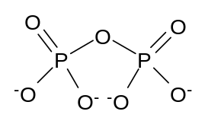
III sahpe:tetrahedral wrt P; V-shaped wrt O
Bond angles: 109.5º wrt P; 105º wrt O

